**MINI PROJECT**

**IMAGE STEGANOGRAPHY**

**Abstract:**

What is it?

Steganography is the art of hiding the fact that communication is taking place, by hiding information in other information.

What steganography essentially does is exploit human perception, human senses are not trained to look for files that have information inside of them. The most common use of steganography is to hide a file inside another file.

How is it different from Cryptography?

Steganography is often confused with cryptology because the two are similar in the way that they both are used to protect important information. The difference between two is that steganography involves hiding information so it appears that no information is hidden at all.

What will we work on?

* Steganography is hiding secret messages in audio, vedio and image files.
* We choose to implement Image steganography using LSB(least significant bits) algorithm and C language.

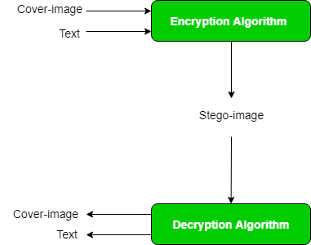 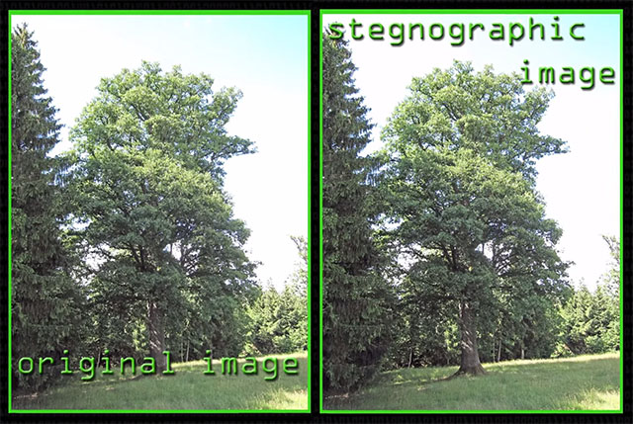

Team number: B24

Roll numbers: 018, 026

Names: M.K.Sripriya, Rehnuma Parveen

GitHub profiles: 1) <https://github.com/sripriyamaturi>

2) <https://github.com/Rehnumaparveen>

Mini-Project repository: <https://github.com/sripriyamaturi/mini-project>